

PCC Company Overview

Taking high-tech to new heights.

The journey of Park Controls and Communications Private Limited (PCC) is one of humble beginnings, unwavering dedication, and a commitment to building a lasting legacy in the defence and aerospace sectors. After three decades of displaying ingenuity and consistently delivering top quality, PCC has established itself as a leader and titan of the industry.

Founded in 1989, PCC has spent 35 years creating and improving a wide range of products and services. We have built up a diverse portfolio of products including Telemetry Data Acquisition Systems, Precision Timing & Control Systems, and various other components for the Air Force, Navy, and Military Ground Forces. PCC gained a good reputation quickly thanks to our future-ready approach and the ability to completely customize products for highly specific requirements in the defence sector.

As we look to the future, we hope to build a legacy of trust, collaboration, and progress—one that will continue to inspire and empower the industry and nation.

**"Scientists discover that which exists. An engineer creates that which never was."**

**Theodore Von Karman -**Mathematician, aerospace engineer, physicist.

Sliders:



Driving Data Acquisition while Powering Precision

The **Health & Utility Management Systems (HUMS) Data Acquisition Unit is a future-ready solution to** monitor and assess the health and performance of critical flight instruments and systems.

(Read more)

Tailored to meet the demands of dynamic flight conditions, the (on-board) Health and Utility Management Systems provide actionable insights into the performance and condition of critical flight components. From detecting potential faults to optimizing maintenance schedules, HUMS empowers operators to reduce downtime, enhance operational efficiency, and ensure regulatory compliance. By integrating advanced data acquisition and real-time monitoring technologies, these systems enable smarter decision-making through intuitive interfaces and robust connectivity.

Control Refined. Performance Redefined.

The **Full Authority Digital Engine Control (FADEC)** is one of the leading Power Control Systems that enables simpler and more efficient management of the flight engine and its components.

(Read more)

The Full Authority Digital Engine Control (FADEC) systems leverage sophisticated algorithms and digital precision to enable top-tier engine performance and consistency across a wide range of conditions. These systems continuously monitor and manage critical parameters like fuel flow, engine temperature, and thrust levels. They adapt in real time to changing flight conditions and deliver peak performance while reducing overall pilot workload. Designed for durability and seamless integration, FADEC represents the pinnacle of modern aerospace engineering, driving innovation in both commercial and military aviation.

Raising the Standard for Seamless Synchronization

These systems provide highly accurate timekeeping modes that are vital for aviation, telecommunications, and defence data centres. It keeps the time consistent across multiple airborne instruments and ground locations

(Read more)

Precision timing systems are the backbone of synchronized operations across aviation and aerospace industries. Engineered for reliability in extreme conditions, the Precision Timing Systems integrate advanced technologies such as atomic clocks and GPS synchronization to maintain stability. Whether managing flight trajectories or supporting mission-critical tasks, they provide the foundation for precision, efficiency, and safety in complex aviation environments.

CORE COMPETENCIES

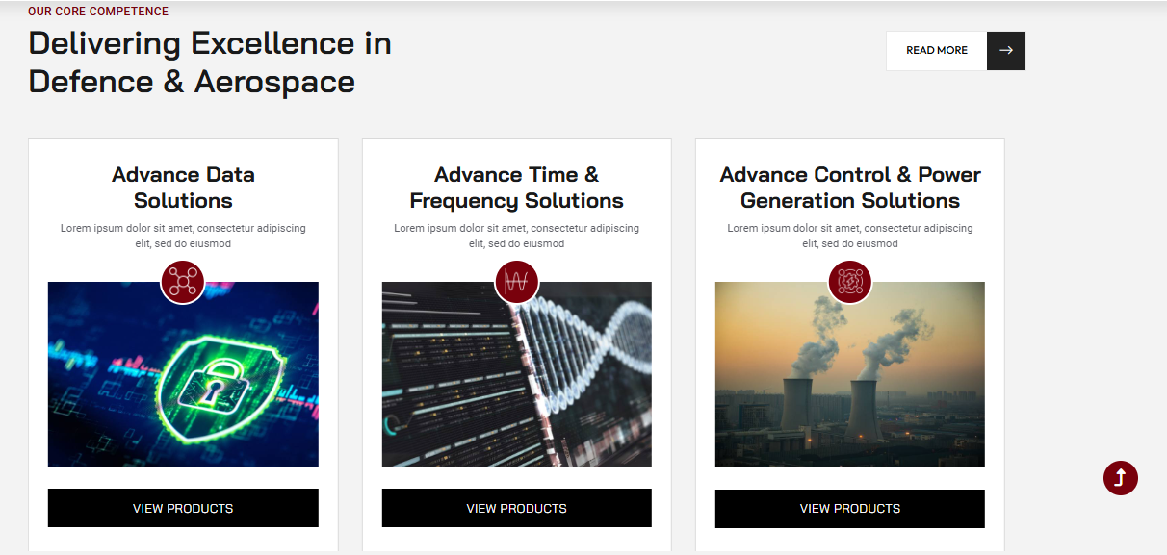

**Advanced Avionics Solutions**

Creating Smarter, Safer, and Highly Efficient Systems for On-board & Ground Operations.

**Precise Time & Frequency solutions**

Delivering Perfection where every Second Matters.

**Control Solutions**

Ensuring Consistent Performance for Mission-Critical Applications

**Select Custom Solutions**

Redefining complex requirements with adaptable innovations.



**300+** Products Introduced

***275+*** Engineering Partners

35+ Years of Expertise

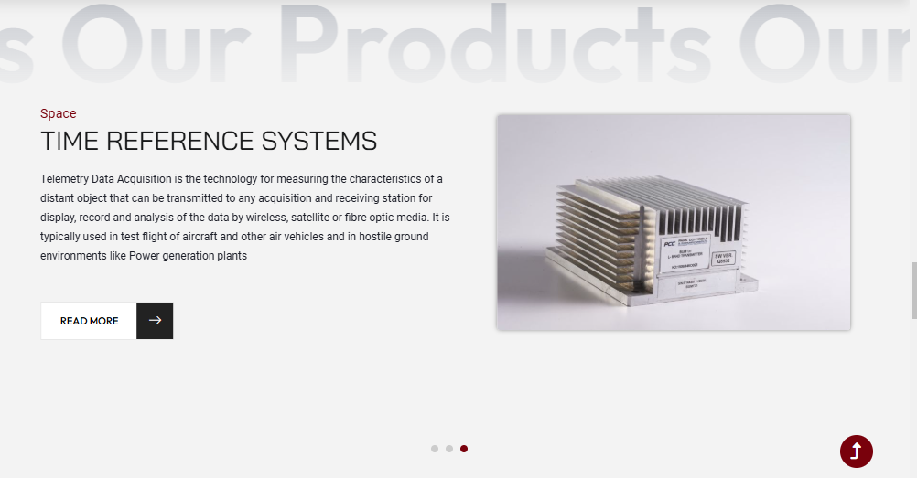

1. ITD

Land

Ground Telemetry Reception & Data Processing Systems

Ground Telemetry Reception & Data Processing Systems are integral for capturing and processing real-time telemetry data from airborne or satellite systems. Using advanced signal processing, data compression, and error correction techniques, these systems ensure efficient data transmission and high reliability. Ruggedized and designed for high-performance environments, these systems are essential for mission-critical operations where precision is paramount. The Ground Telemetry Data systems aim to accurately provide real-time insights for operational efficiency and reliability.

1. EIU

Air

Engine Instrumentation Unit

The PARK - Engine Instrumentation Unit (EIU) enhances reliability and safety by providing real-time engine parameter monitoring. It comes with a range of advanced data acquisition capabilities and supports predictive maintenance while minimizing downtime and maximizing operational efficiency. Equipped with robust diagnostics, it optimizes engine performance and extends its lifecycle, making it an indispensable tool for modern propulsion systems. It is a highly useful unit in the field of aviation and defence.

1. Sea

PARK PGMCLK-24E

There are different kinds of Countdown Timing Systems and Countdown Generators that are suitable for land-based and ship-based launch applications, or ground check out applications. On a battleship or naval cruiser that has multiple computers and hardware, it is essential that they all generate or display the same time, synchronized down to the millisecond. These Clocks and Timers can be connected by Ethernet or by analogue systems, they are also compact and ruggedized making them highly suitable for transport to remote locations.



Cutting-edge Technology Tailored to your Defence, Aerospace, and Industrial needs

LET’S CONNECT

(Remove Blog Section for now)



Only Keep:

BHE

GDP

ASystel